ELL409   
Assignment 2

Vansh Gupta  
2019EE10143

**Appendix:**

* CVXOPT linear kernel derivation:

**Part 1A**

* **Binary Classification**:
* **Linear Kernel**
* Note, here’s my understanding of the parameter C, based on [this](https://stats.stackexchange.com/questions/31066/what-is-the-influence-of-c-in-svms-with-linear-kernel): *The C parameter tells the SVM optimization how much you want to avoid misclassifying each training example. For large values of C, the optimization will choose a smaller-margin hyperplane if that hyperplane does a better job of getting all the training points classified correctly. Conversely, a very small value of C will cause the optimizer to look for a larger-margin separating hyperplane, even if that hyperplane misclassifies more points. For very tiny values of C, you should get misclassified examples, often even if your training data is linearly separable.* i.e., it kind of acts as a regularization constant

First, I take the linear kernel, for which, the only parameter is C (Because the degree is introduced in the separate poly kernel). Further, I first consider only 1st 10 features for this sub-part and then 25 features for each pair of target values. I have reported the combined results in table 1.

First, I take the first 10 features, split the dataset in 4:1 training:test set and run a 5-fold CV on the training set for the results. I took the best parameters returned by the grid search, and used them to train an SVM classifier but without the standard scaler. I again took these “best parameters” to train the model through CVXOPT and reported the score (accuracies) and support vectors for each of the cases.  
We know that a greater number of attributes/features would make the model more complex and increase the number of support vectors. It is also confirmed by the outputs.  
The plots are of 2 types. First is the score (mean accuracy) for different values of C, and the second is an error bar for the mean score for the 5-fold CV, spanning the standard deviation about mean. A similar approach is repeated while considering all of the 25 features.

Note: Most of the report below is directly copied from the output of a nice pipeline that I made

#################################################################################

Labels: 0 , 1

Number of features: 10

#################################################################################

Number of training examples: (484, 10) (484, 1)  
Number of test examples: (121, 10) (121, 1)

--------------------------LIBSVM-----------------------------

The Best parameters according to grid search are: {'SVM__C': 10.0}  
Training score for LIBSVM with best parameters: 100.0 %  
Test score for LIBSVM with best parameters: 99.17355371900827 %

Indices of support vectors as returned by LIBSVM: [41, 78, 261, 275, 280, 284, 346, 382, 432, 472]

--------------------------CVXOPT-----------------------------

Test score for CVXOPT with best parameters: 99.17355371900827 %  
Indices of support vectors as returned by CVXOPT: [41, 78, 261, 275, 280, 284, 346, 382, 432, 472]

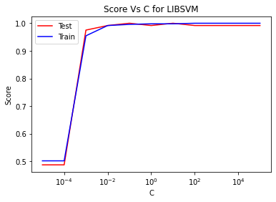

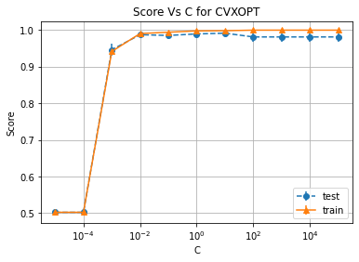

#################################################################################

Labels: 0 , 1  
Number of features: 25

#################################################################################

Number of training examples: (484, 25) (484, 1)  
Number of test examples: (121, 25) (121, 1)

--------------------------LIBSVM-----------------------------

The Best parameters according to grid search are: {'SVM__C': 0.1}  
Training score for LIBSVM with best parameters: 100.0 %  
Test score for LIBSVM with best parameters: 99.17355371900827 %  
Indices of support vectors as returned by LIBSVM: [13, 19, 27, 78, 84, 96, 149, 176, 261, 275, 282, 285, 322, 346, 372, 382, 401, 403, 472]

--------------------------CVXOPT-----------------------------

Test score for CVXOPT with best parameters: 99.17355371900827 %  
Indices of support vectors as returned by CVXOPT: [13, 19, 27, 78, 84, 96, 149, 176, 261, 275, 282, 285, 322, 346, 372, 382, 401, 403, 472]

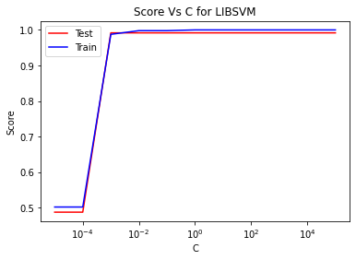

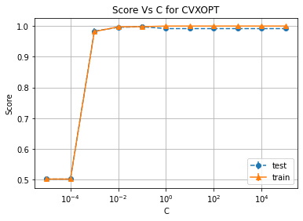

#################################################################################

Labels: 4 , 6

Number of features: 10

#################################################################################

Number of training examples: (472, 10) (472, 1)  
Number of test examples: (119, 10) (119, 1)

--------------------------LIBSVM-----------------------------

The Best parameters according to grid search are: {'SVM__C': 0.01}  
Training score for LIBSVM with best parameters: 97.66949152542372 %  
Test score for LIBSVM with best parameters: 100.0 %  
Indices of support vectors as returned by LIBSVM: [0, 1, 3, 11, 14, 18, 32, 33, 39, 40, 43, 44, 46, 47, 51, 52, 54, 58, 60, 61, 66, 71, 73, 78, 80, 92, 93, 110, 116, 120, 123, 126, 130, 139, 140, 141, 142, 150, 153, 162, 164, 168, 170, 181, 183, 194, 197, 199, 202, 213, 221, 235, 236, 238, 239, 244, 246, 255, 257, 258, 262, 267, 269, 272, 273, 275, 276, 278, 280, 289, 293, 294, 295, 302, 303, 305, 306, 319, 331, 332, 340, 341, 348, 352, 353, 364, 370, 375, 376, 380, 381, 382, 389, 390, 392, 393, 395, 402, 403, 406, 411, 412, 415, 418, 420, 421, 427, 435, 440, 450, 464, 465, 468, 469]

--------------------------CVXOPT-----------------------------

Test score for CVXOPT with best parameters: 100.0 %  
Indices of support vectors as returned by CVXOPT: [0, 1, 3, 11, 14, 18, 32, 33, 39, 40, 43, 44, 46, 47, 51, 52, 54, 58, 60, 61, 66, 71, 73, 78, 80, 92, 93, 110, 116, 120, 123, 126, 130, 139, 140, 141, 142, 150, 153, 162, 164, 168, 170, 181, 183, 194, 197, 199, 202, 213, 221, 235, 236, 238, 239, 244, 246, 255, 257, 258, 262, 267, 269, 272, 273, 275, 276, 278, 280, 289, 293, 294, 295, 302, 303, 305, 306, 319, 331, 332, 340, 341, 348, 352, 353, 364, 370, 375, 376, 380, 381, 382, 389, 390, 392, 393, 395, 402, 403, 406, 411, 412, 415, 418, 420, 421, 427, 435, 440, 450, 464, 465, 468, 469]

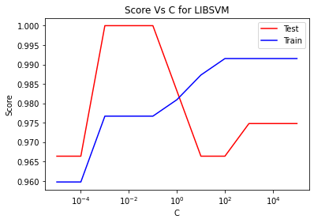

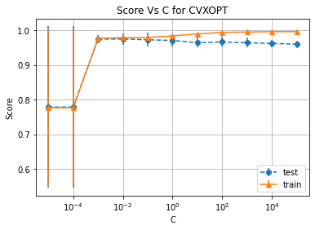

#################################################################################

Labels: 4 , 6

Number of features: 25

#################################################################################

Number of training examples: (472, 25) (472, 1)  
Number of test examples: (119, 25) (119, 1)

--------------------------LIBSVM-----------------------------

The Best parameters according to grid search are: {'SVM__C': 0.1}  
Training score for LIBSVM with best parameters: 98.9406779661017 %  
Test score for LIBSVM with best parameters: 100.0 %  
Indices of support vectors as returned by LIBSVM: [0, 11, 14, 43, 44, 51, 52, 61, 66, 73, 83, 94, 133, 140, 142, 150, 153, 164, 170, 194, 199, 221, 234, 235, 272, 275, 276, 280, 289, 294, 302, 319, 352, 381, 390, 395, 414, 420, 426, 435, 440, 450]

--------------------------CVXOPT-----------------------------

Test score for CVXOPT with best parameters: 100.0 %  
Indices of support vectors as returned by CVXOPT: [0, 11, 14, 43, 44, 51, 52, 61, 66, 73, 83, 94, 133, 140, 142, 150, 153, 164, 170, 194, 199, 221, 234, 235, 272, 275, 276, 280, 289, 294, 302, 319, 352, 381, 390, 395, 414, 420, 426, 435, 440, 450]

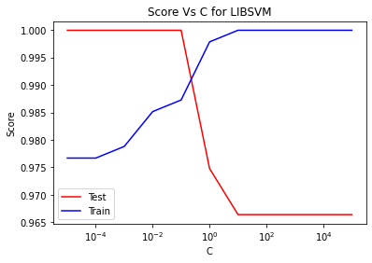

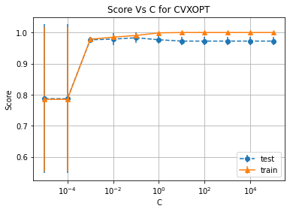

#################################################################################

Labels: 8 , 9

Number of features: 10

#################################################################################

Number of training examples: (454, 10) (454, 1)  
Number of test examples: (114, 10) (114, 1)

--------------------------LIBSVM-----------------------------

The Best parameters according to grid search are: {'SVM__C': 0.01}  
Training score for LIBSVM with best parameters: 92.95154185022027 %  
Test score for LIBSVM with best parameters: 93.85964912280701 %  
Indices of support vectors as returned by LIBSVM: [3, 7, 8, 10, 13, 14, 15, 17, 20, 24, 29, 33, 34, 36, 37, 42, 45, 53, 57, 59, 62, 70, 75, 79, 82, 83, 86, 90, 97, 101, 108, 109, 112, 114, 132, 134, 137, 138, 141, 146, 148, 149, 150, 153, 157, 163, 167, 172, 180, 186, 194, 198, 199, 201, 202, 209, 211, 212, 215, 221, 223, 224, 225, 226, 229, 230, 233, 236, 237, 242, 248, 251, 256, 260, 261, 263, 265, 266, 267, 273, 275, 276, 278, 282, 283, 286, 287, 288, 294, 297, 298, 299, 300, 315, 322, 323, 325, 326, 329, 330, 331, 337, 340, 342, 351, 355, 358, 362, 367, 369, 370, 371, 375, 376, 380, 381, 384, 386, 388, 389, 391, 396, 398, 399, 400, 403, 406, 407, 408, 410, 412, 414, 415, 416, 418, 419, 420, 421, 423, 427, 430, 431, 432, 433, 435, 439, 440, 441, 448, 450]

--------------------------CVXOPT-----------------------------

Test score for CVXOPT with best parameters: 93.85964912280701 %  
Indices of support vectors as returned by CVXOPT: [3, 7, 8, 10, 13, 14, 15, 17, 20, 24, 29, 33, 34, 36, 37, 42, 45, 53, 57, 59, 62, 70, 75, 79, 82, 83, 86, 90, 97, 101, 108, 109, 112, 114, 132, 134, 137, 138, 141, 146, 148, 149, 150, 153, 157, 163, 167, 172, 180, 186, 194, 198, 199, 201, 202, 209, 211, 212, 215, 221, 223, 224, 225, 226, 229, 230, 233, 236, 237, 242, 248, 251, 256, 260, 261, 263, 265, 266, 267, 273, 275, 276, 278, 282, 283, 286, 287, 288, 294, 297, 298, 299, 300, 315, 322, 323, 325, 326, 329, 330, 331, 337, 340, 342, 351, 355, 358, 362, 367, 369, 370, 371, 375, 376, 380, 381, 384, 386, 388, 389, 391, 396, 398, 399, 400, 403, 406, 407, 408, 410, 412, 414, 415, 416, 418, 419, 420, 421, 423, 427, 430, 431, 432, 433, 435, 439, 440, 441, 448, 450]

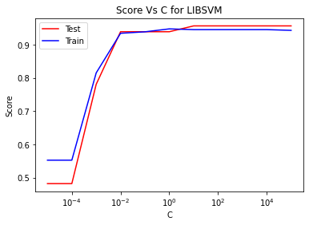

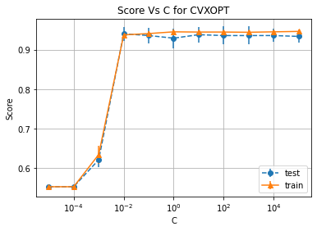

#################################################################################

Labels: 8 , 9

Number of features: 25

#################################################################################

Number of training examples: (454, 25) (454, 1)  
Number of test examples: (114, 25) (114, 1)

--------------------------LIBSVM-----------------------------

The Best parameters according to grid search are: {'SVM__C': 0.1}  
Training score for LIBSVM with best parameters: 97.13656387665198 %  
Test score for LIBSVM with best parameters: 97.36842105263158 %  
Indices of support vectors as returned by LIBSVM: [3, 13, 14, 24, 28, 33, 34, 37, 45, 53, 57, 62, 82, 90, 101, 132, 149, 153, 155, 157, 172, 186, 190, 191, 199, 201, 202, 212, 230, 231, 236, 244, 260, 261, 267, 288, 314, 322, 323, 331, 340, 351, 355, 362, 369, 377, 380, 381, 392, 398, 400, 403, 406, 407, 415, 416, 419, 420, 423, 439, 441, 442, 448, 450]

--------------------------CVXOPT-----------------------------

Test score for CVXOPT with best parameters: 97.36842105263158 %  
Indices of support vectors as returned by CVXOPT: [3, 13, 14, 24, 28, 33, 34, 37, 45, 53, 57, 62, 82, 90, 101, 132, 149, 153, 155, 157, 172, 186, 190, 191, 199, 201, 202, 212, 230, 231, 236, 244, 260, 261, 267, 288, 314, 322, 323, 331, 340, 351, 355, 362, 369, 377, 380, 381, 392, 398, 400, 403, 406, 407, 415, 416, 419, 420, 423, 439, 441, 442, 448, 450]

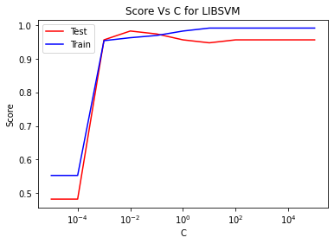

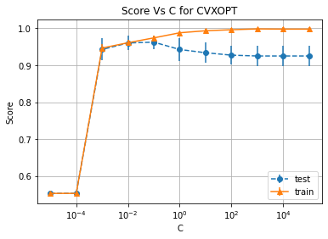

**Linear kernel**

|  |  |  |  |  |  |  |
| --- | --- | --- | --- | --- | --- | --- |
| **Class A** | **Class B** | **Number of features** | **Best C** | **SVM training accuracy** | **SVM test accuracy** | **CVXOPT test accuracy** |
| 0 | 1 | 10 | 10 | 100% | 99.17% | 99.17% |
| 0 | 1 | 25 | 0.1 | 100% | 99.17% | 99.17% |
| 4 | 6 | 10 | 0.01 | 97.67% | 100% | 100% |
| 4 | 6 | 25 | 0.1 | 98.94% | 100% | 100% |
| 8 | 9 | 10 | 0.01 | 92.95% | 93.86% | 93.86% |
| 8 | 9 | 25 | 0.1 | 97.14% | 97.37% | 97.37% |

Table 1.

**Discussion**

As we can see, the test accuracy is same for Libsvm and CVXOPT. Even the support vectors for both are same (Printed in sorted order, so that can also be confirmed by human inspection)

By the various graphs, one can see that the smaller values of C lead to underfitting, while the higher value of C leads to overfitting. This is not *that* clearly visible because we have 25 features which makes the model complex enough to prevent overfitting.

By looking at the table 1, we can easily conclude that as the number of features increase, the test accuracy either remains the same or increases, which is also what we expect because we are increasing the complexity of the model. Since it is a linear classifier, maybe that is why for the pair (0,1) there isn’t any increase when number of features are increase 2.5 times

* **Poly Kernel**
* For the poly kernel, we have 2 more parameters, gamma (kernel coefficient) and degree (of the polynomial). The default value of the *independent term* is 0 by default. Since it has little to no bearing on the result (since I am anyway using a standard scaler), I keep it as 0

I first consider only 1st 10 features for this sub-part, followed by all 25 features to finally report the results in the table 2.

I take the first 10 features, split the dataset in 4:1 training:test set and run a 5-fold CV on the training set for the results. Having 3 different parameters, there was no definite way to represent the scores on a graph (4D), therefore I only have single set of graphs for this, which are error bars for the mean score for the 5-fold CV, spanning the std dev about mean for all the parameters. Same is done for 25 features iteration  
Note: Zoom in on the graph for better visibility

#################################################################################

Labels: 0 , 1  
Number of features: 10

#################################################################################

Number of training examples: (484, 10) (484, 1)  
Number of test examples: (121, 10) (121, 1)

--------------------------LIBSVM-----------------------------

The Best parameters according to grid search are: {'SVM__C': 0.01, 'SVM__degree': 1.0, 'SVM__gamma': 1000.0}  
Training score for LIBSVM with best parameters: 100.0 %  
Test score for LIBSVM with best parameters: 99.17355371900827 %  
Indices of support vectors as returned by LIBSVM: [41, 78, 261, 275, 280, 284, 346, 382, 432, 472]

--------------------------CVXOPT-----------------------------

Test score for CVXOPT with best parameters: 99.17355371900827 %  
Indices of support vectors as returned by CVXOPT: [41, 78, 261, 275, 280, 284, 346, 382, 432, 472]

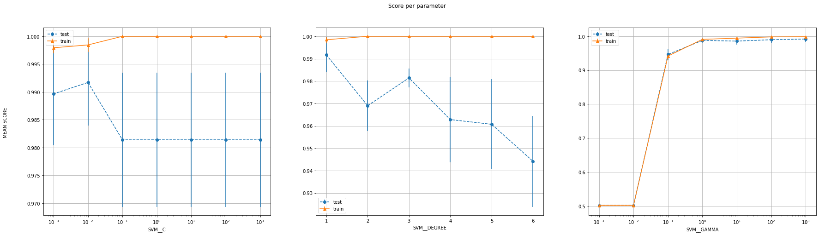

#################################################################################

Labels: 0 , 1  
Number of features: 25

#################################################################################

Number of training examples: (484, 25) (484, 1)  
Number of test examples: (121, 25) (121, 1)

--------------------------LIBSVM-----------------------------

The Best parameters according to grid search are: {'SVM__C': 0.001, 'SVM__degree': 1.0, 'SVM__gamma': 100.0}  
Training score for LIBSVM with best parameters: 100.0 %  
Test score for LIBSVM with best parameters: 99.17355371900827 %  
Indices of support vectors as returned by LIBSVM: [13, 19, 27, 78, 84, 96, 149, 176, 261, 275, 282, 285, 322, 346, 372, 382, 401, 403, 472]

--------------------------CVXOPT-----------------------------

Test score for CVXOPT with best parameters: 99.17355371900827 %  
Indices of support vectors as returned by CVXOPT: [13, 19, 78, 96, 149, 176, 261, 275, 282, 285, 346, 372, 382, 403, 472]

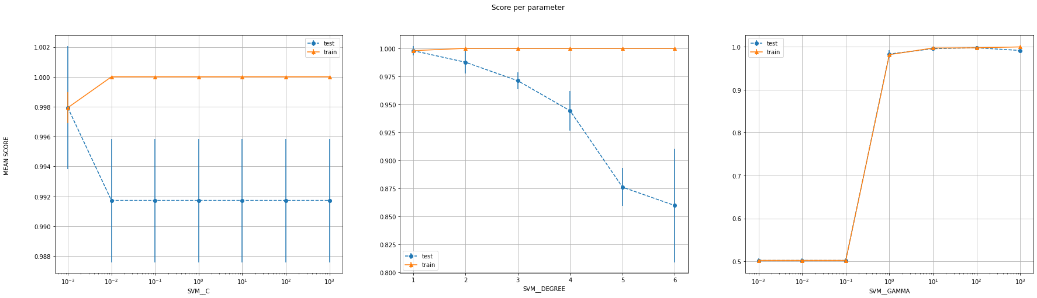

#################################################################################

Labels: 4 , 6

Number of features: 10

#################################################################################

Number of training examples: (472, 10) (472, 1)  
Number of test examples: (119, 10) (119, 1)

--------------------------LIBSVM-----------------------------

The Best parameters according to grid search are: {'SVM__C': 0.1, 'SVM__degree': 3.0, 'SVM__gamma': 0.1}  
Training score for LIBSVM with best parameters: 99.36440677966102 %  
Test score for LIBSVM with best parameters: 100.0 %  
Indices of support vectors as returned by LIBSVM: [0, 2, 3, 11, 18, 39, 43, 44, 46, 47, 51, 52, 58, 60, 64, 66, 71, 73, 78, 80, 82, 89, 92, 93, 99, 110, 116, 126, 131, 136, 140, 142, 150, 153, 164, 168, 174, 181, 183, 194, 202, 213, 227, 231, 234, 236, 238, 239, 244, 246, 267, 269, 272, 275, 276, 278, 280, 286, 287, 289, 294, 302, 303, 305, 306, 314, 319, 349, 352, 353, 356, 360, 363, 364, 367, 374, 375, 376, 380, 382, 390, 393, 395, 402, 403, 414, 415, 418, 420, 421, 426, 427, 428, 430, 435, 440, 450, 464, 465, 466, 468, 469]

--------------------------CVXOPT-----------------------------

Test score for CVXOPT with best parameters: 100.0 %  
Indices of support vectors as returned by CVXOPT: [0, 2, 3, 11, 18, 39, 43, 44, 46, 47, 51, 52, 58, 60, 64, 66, 71, 73, 78, 80, 82, 89, 92, 93, 99, 110, 116, 126, 131, 136, 140, 142, 150, 153, 164, 168, 174, 181, 183, 194, 199, 202, 213, 227, 231, 234, 236, 238, 239, 244, 246, 267, 269, 272, 275, 276, 278, 280, 286, 287, 289, 294, 302, 303, 305, 306, 314, 319, 349, 352, 353, 356, 360, 363, 364, 367, 374, 375, 376, 380, 382, 390, 393, 395, 402, 403, 414, 415, 418, 420, 421, 426, 427, 428, 430, 435, 440, 450, 464, 465, 466, 468, 469]

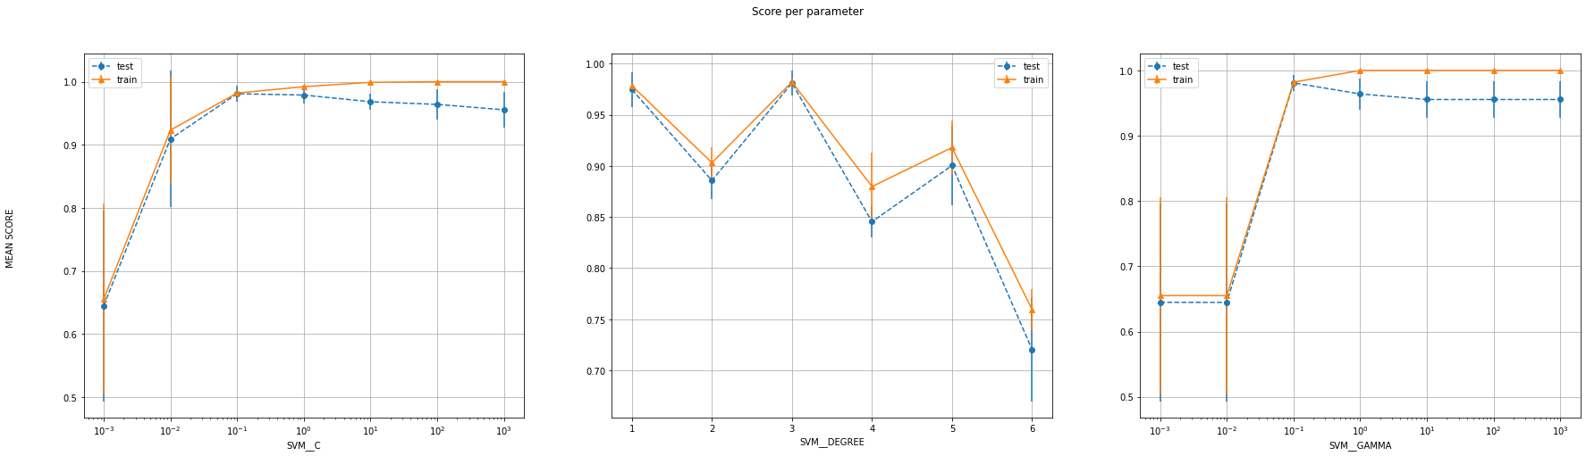

#################################################################################

Labels: 4 , 6

Number of features: 25

#################################################################################

Number of training examples: (472, 25) (472, 1)  
Number of test examples: (119, 25) (119, 1)

--------------------------LIBSVM-----------------------------

The Best parameters according to grid search are: {'SVM__C': 0.01, 'SVM__degree': 3.0, 'SVM__gamma': 0.1}  
Training score for LIBSVM with best parameters: 99.57627118644068 %  
Test score for LIBSVM with best parameters: 98.31932773109243 %  
Indices of support vectors as returned by LIBSVM: [0, 2, 7, 11, 14, 18, 19, 23, 25, 32, 33, 34, 38, 39, 41, 43, 44, 45, 46, 47, 51, 52, 53, 58, 60, 61, 64, 66, 67, 71, 73, 78, 80, 81, 82, 83, 89, 92, 93, 94, 99, 102, 103, 106, 110, 116, 123, 126, 129, 130, 131, 132, 133, 136, 140, 141, 142, 144, 146, 150, 152, 153, 157, 162, 163, 164, 166, 168, 170, 172, 174, 177, 178, 181, 183, 194, 196, 197, 199, 202, 207, 211, 213, 214, 217, 219, 221, 223, 225, 227, 231, 234, 235, 236, 238, 239, 244, 246, 248, 252, 259, 267, 272, 273, 275, 276, 278, 280, 284, 286, 287, 289, 290, 294, 302, 303, 305, 306, 309, 312, 314, 315, 316, 318, 319, 326, 327, 328, 330, 332, 336, 340, 343, 348, 349, 352, 353, 354, 356, 360, 361, 362, 363, 364, 367, 368, 374, 375, 376, 382, 388, 389, 390, 392, 393, 395, 402, 403, 405, 406, 412, 414, 415, 416, 417, 418, 420, 421, 426, 427, 428, 430, 435, 438, 440, 441, 442, 443, 445, 450, 460, 464, 465, 466, 469, 470]

--------------------------CVXOPT-----------------------------

Test score for CVXOPT with best parameters: 99.15966386554622 %  
Indices of support vectors as returned by CVXOPT: [0, 2, 7, 11, 14, 18, 19, 23, 25, 32, 33, 34, 38, 39, 41, 43, 44, 45, 46, 47, 51, 52, 53, 58, 60, 61, 64, 66, 67, 71, 73, 78, 80, 81, 82, 83, 89, 92, 93, 94, 99, 102, 103, 106, 110, 116, 123, 126, 129, 130, 131, 132, 133, 136, 140, 141, 142, 144, 146, 150, 152, 153, 157, 162, 163, 164, 166, 168, 170, 172, 174, 177, 178, 181, 183, 194, 196, 197, 199, 202, 207, 211, 213, 214, 217, 219, 221, 223, 225, 227, 231, 234, 235, 236, 238, 239, 244, 246, 248, 252, 259, 267, 272, 273, 275, 276, 278, 280, 284, 286, 287, 289, 290, 294, 302, 303, 305, 306, 309, 312, 314, 315, 316, 318, 319, 326, 327, 328, 330, 332, 336, 340, 343, 348, 349, 352, 353, 354, 356, 360, 361, 362, 363, 364, 367, 368, 374, 375, 376, 382, 388, 389, 390, 392, 393, 395, 402, 403, 405, 406, 412, 414, 415, 416, 417, 418, 420, 421, 426, 427, 428, 430, 435, 438, 440, 441, 442, 443, 445, 450, 460, 464, 465, 466, 469, 470]

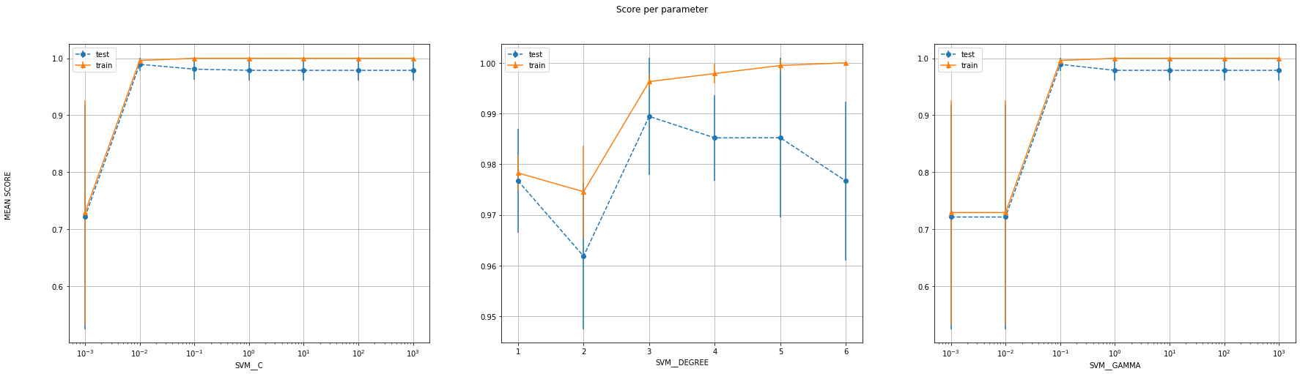

#################################################################################

Labels: 8 , 9  
Number of features: 10

#################################################################################

Number of training examples: (454, 10) (454, 1)  
Number of test examples: (114, 10) (114, 1)

--------------------------LIBSVM-----------------------------

The Best parameters according to grid search are: {'SVM__C': 1.0, 'SVM__degree': 3.0, 'SVM__gamma': 0.1}  
Training score for LIBSVM with best parameters: 99.77973568281938 %  
Test score for LIBSVM with best parameters: 94.73684210526315 %  
Indices of support vectors as returned by LIBSVM: [3, 12, 13, 14, 20, 24, 32, 33, 36, 37, 39, 42, 44, 45, 51, 57, 63, 70, 76, 79, 80, 82, 90, 132, 137, 141, 149, 157, 172, 191, 199, 202, 212, 218, 221, 224, 225, 229, 230, 232, 236, 242, 245, 248, 256, 260, 261, 263, 266, 283, 286, 289, 294, 297, 301, 326, 329, 337, 340, 345, 351, 355, 362, 370, 371, 373, 374, 375, 376, 381, 398, 399, 402, 407, 408, 410, 412, 415, 416, 418, 430, 439, 447, 448]

--------------------------CVXOPT-----------------------------

Test score for CVXOPT with best parameters: 94.73684210526316 %  
Indices of support vectors as returned by CVXOPT: [3, 12, 13, 14, 20, 24, 32, 33, 36, 37, 39, 42, 44, 45, 51, 57, 63, 70, 76, 79, 80, 82, 90, 132, 137, 141, 149, 157, 172, 191, 199, 202, 212, 218, 221, 224, 225, 229, 230, 232, 236, 242, 245, 248, 256, 260, 261, 263, 266, 283, 286, 289, 294, 297, 301, 326, 329, 337, 340, 345, 351, 355, 362, 370, 371, 373, 374, 375, 376, 381, 398, 399, 402, 407, 408, 410, 412, 415, 416, 418, 430, 439, 447, 448]

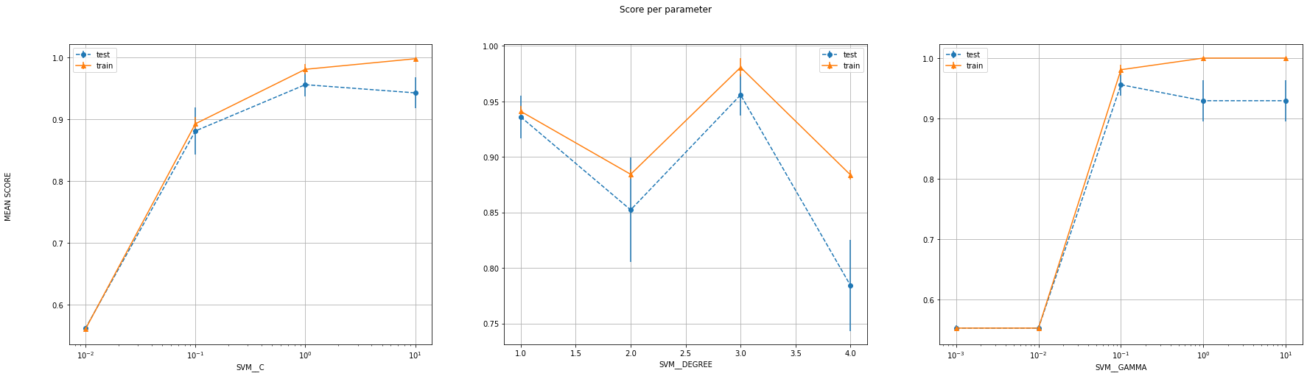

#################################################################################

Labels: 8 , 9  
Number of features: 25

#################################################################################

Number of training examples: (454, 25) (454, 1)  
Number of test examples: (114, 25) (114, 1)

--------------------------LIBSVM-----------------------------

The Best parameters according to grid search are: {'SVM__C': 0.01, 'SVM__degree': 1.0, 'SVM__gamma': 10.0}  
Training score for LIBSVM with best parameters: 97.13656387665198 %  
Test score for LIBSVM with best parameters: 97.36842105263158 %  
Indices of support vectors as returned by LIBSVM: [3, 13, 14, 24, 28, 33, 34, 37, 45, 53, 57, 62, 82, 90, 101, 132, 149, 153, 155, 157, 172, 186, 190, 191, 199, 201, 202, 212, 230, 231, 236, 244, 260, 261, 267, 288, 314, 322, 323, 331, 340, 351, 355, 362, 369, 377, 380, 381, 392, 398, 400, 403, 406, 407, 415, 416, 419, 420, 423, 439, 441, 442, 448, 450]

--------------------------CVXOPT-----------------------------

Test score for CVXOPT with best parameters: 97.36842105263158 %  
Indices of support vectors as returned by CVXOPT: [3, 13, 14, 24, 28, 33, 34, 37, 45, 53, 57, 62, 82, 90, 101, 132, 149, 153, 155, 157, 172, 186, 190, 191, 199, 201, 202, 212, 230, 231, 236, 244, 260, 261, 267, 288, 314, 322, 323, 331, 340, 351, 355, 362, 369, 377, 380, 381, 392, 398, 400, 403, 406, 407, 415, 416, 419, 420, 423, 439, 441, 442, 448, 450]

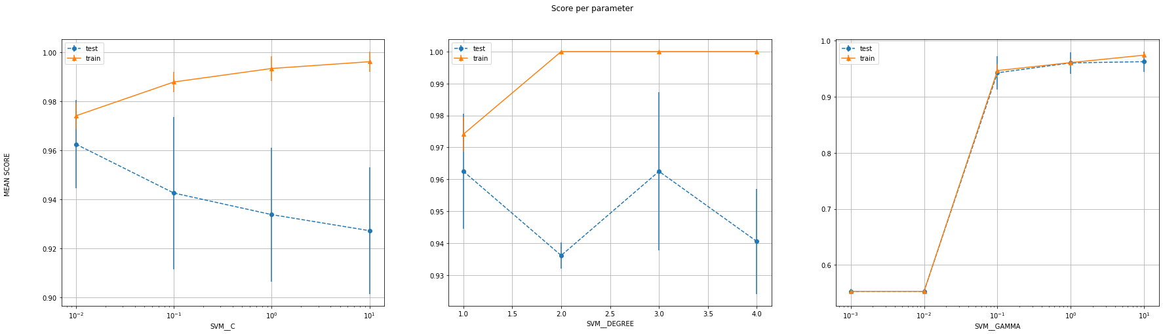

**Poly Kernel**

|  |  |  |  |  |  |  |  |  |
| --- | --- | --- | --- | --- | --- | --- | --- | --- |
| **Class A** | **Class B** | **Num of features** | **Best C** | **Best gamma** | **Best degree** | **SVM train score** | **SVM test score** | **CVXOPT test score** |
| 0 | 1 | 10 | 0.01 | 1000 | 1 | 100% | 99.17% | 99.17% |
| 0 | 1 | 25 | 0.001 | 100 | 1 | 100% | 99.17% | 99.17% |
| 4 | 6 | 10 | 0.1 | 0.1 | 3 | 99.36% | 100% | 100% |
| 4 | 6 | 25 | 0.01 | 0.1 | 3 | 99.58% | 98.32% | 99.16% |
| 8 | 9 | 10 | 1 | 0.1 | 3 | 99.78% | 94.74% | 94.74% |
| 8 | 9 | 25 | 0.01 | 10 | 1 | 97.14% | 97.37% | 97.37% |

Table 2.

**Discussion**

By looking at the table 2, we can conclude that as the number of features increase, the test accuracy either remains the same or increases, which is also what we expect because we are increasing the complexity of the model. For the pair (8,9), the training score is decreasing which indicates that for 10 features, it was experiencing overfitting

When we look at the graphs that we plotted, we see a similar trend across all the parameters. The training error and the test error start low (Underfitting region) and the training keeps on increasing while the test error reaches a maximum (Optimal best value) and starts decreasing (Overfitting). However, the trend is not exactly the same and we can conclude that degree and C are much more prone to overfitting compared with gamma, which barely shows this trend

* **RBF Kernel**
* For the rbf kernel, we have 2 parameters, gamma (kernel coefficient) and C (degree of margin). The default value of the *independent term* is 0 by default. Since it has little to no bearing on the result (asI am anyway using a standard scaler), I keep it as 0

I first consider only 1st 10 features for this sub-part, followed by all 25 features to finally report the results in the table 3.

I take the first 10 features, split the dataset in 4:1 training:test set and run a 5-fold CV on the training set for the results. Having 2 different parameters, there was a definite way to represent the scores on a grap, but lacking continuous values, the contour plot was not very informative, and the wireframe was illegible. Therefore, I only have single set of graphs for this, which are error bars for the mean score for the 5-fold CV, spanning the std dev about mean for all the parameters. Same is done for 25 features iteration.  
Note: Zoom in on the graph for better visibility

#################################################################################

Labels: 0 , 1  
Number of features: 10

#################################################################################

Number of training examples: (484, 10) (484, 1)  
Number of test examples: (121, 10) (121, 1)

--------------------------LIBSVM-----------------------------

The Best parameters according to grid search are: {'SVM__C': 0.1, 'SVM__gamma': 0.1}  
Training score for LIBSVM with best parameters: 99.58677685950413 %  
Test score for LIBSVM with best parameters: 99.17355371900827 %  
Indices of support vectors as returned by LIBSVM: [4, 5, 6, 7, 13, 14, 17, 18, 19, 20, 24, 27, 28, 30, 34, 39, 40, 41, 45, 46, 48, 61, 62, 78, 82, 84, 86, 87, 89, 94, 95, 96, 98, 100, 103, 108, 109, 110, 114, 116, 118, 120, 121, 125, 127, 128, 131, 132, 133, 134, 135, 138, 140, 142, 144, 146, 149, 150, 160, 161, 162, 163, 164, 166, 167, 169, 174, 175, 176, 179, 185, 188, 189, 191, 192, 193, 196, 197, 199, 201, 205, 211, 212, 213, 214, 215, 217, 218, 219, 222, 223, 224, 225, 228, 232, 233, 235, 236, 238, 239, 241, 244, 247, 249, 251, 252, 253, 254, 259, 261, 262, 263, 265, 266, 271, 273, 275, 276, 280, 282, 283, 284, 285, 286, 287, 288, 294, 295, 298, 299, 300, 304, 309, 310, 313, 321, 324, 326, 330, 334, 335, 336, 339, 346, 352, 353, 358, 361, 362, 363, 364, 366, 374, 376, 380, 382, 384, 390, 391, 395, 399, 401, 402, 403, 404, 405, 407, 408, 414, 421, 424, 427, 430, 432, 436, 438, 440, 442, 443, 444, 446, 449, 454, 455, 456, 457, 459, 466, 469, 471, 472, 474, 475, 477, 479, 480, 483]

--------------------------CVXOPT-----------------------------

Test score for CVXOPT with best parameters: 99.17355371900827 %  
Indices of support vectors as returned by CVXOPT: [4, 5, 6, 7, 13, 14, 17, 18, 19, 20, 24, 27, 28, 30, 34, 39, 40, 41, 45, 46, 48, 61, 62, 75, 78, 82, 84, 86, 87, 89, 94, 95, 96, 98, 100, 103, 108, 109, 110, 114, 116, 118, 120, 121, 125, 127, 128, 131, 132, 133, 134, 135, 138, 140, 142, 144, 146, 149, 150, 160, 161, 162, 163, 164, 166, 167, 169, 174, 175, 176, 179, 185, 188, 189, 191, 192, 193, 196, 197, 199, 201, 205, 211, 212, 213, 214, 215, 217, 218, 219, 222, 223, 224, 225, 228, 232, 233, 235, 236, 238, 239, 241, 244, 247, 249, 251, 252, 253, 254, 259, 261, 262, 263, 265, 266, 271, 273, 275, 276, 280, 282, 283, 284, 285, 286, 287, 288, 294, 295, 298, 299, 300, 304, 309, 310, 313, 321, 324, 326, 330, 334, 335, 336, 339, 346, 352, 353, 358, 361, 362, 363, 364, 366, 374, 376, 380, 382, 384, 390, 391, 395, 399, 401, 402, 403, 404, 405, 407, 408, 414, 421, 424, 427, 430, 432, 436, 438, 440, 442, 443, 444, 446, 449, 454, 455, 456, 457, 459, 466, 469, 471, 472, 474, 475, 477, 479, 480, 483]

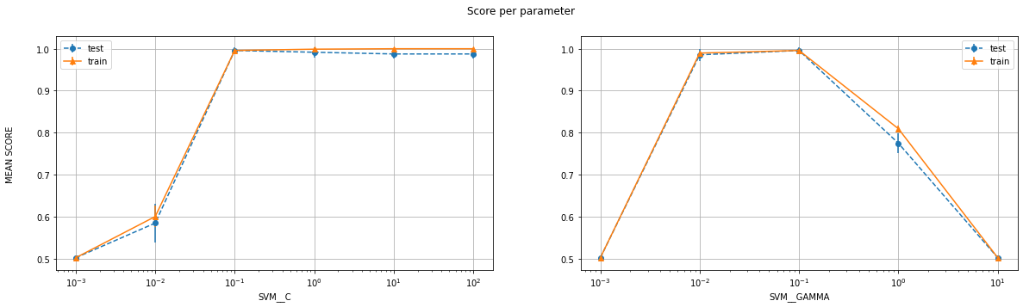

#################################################################################

Labels: 0 , 1  
Number of features: 25

#################################################################################

Number of training examples: (484, 25) (484, 1)  
Number of test examples: (121, 25) (121, 1)

--------------------------LIBSVM-----------------------------

The Best parameters according to grid search are: {'SVM__C': 100.0, 'SVM__gamma': 0.001}  
Training score for LIBSVM with best parameters: 100.0 %  
Test score for LIBSVM with best parameters: 99.17355371900827 %  
Indices of support vectors as returned by LIBSVM: [13, 19, 27, 78, 149, 176, 238, 261, 275, 282, 346, 372, 382, 401, 403, 432, 469, 472]

--------------------------CVXOPT-----------------------------

Test score for CVXOPT with best parameters: 99.17355371900827 %  
Indices of support vectors as returned by CVXOPT: [13, 19, 27, 78, 149, 176, 238, 239, 261, 275, 282, 322, 346, 372, 382, 401, 403, 432, 469, 472]

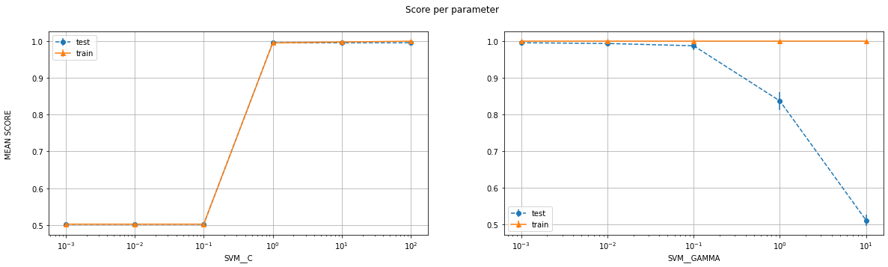

#################################################################################

Labels: 4 , 6  
Number of features: 10

#################################################################################

Number of training examples: (472, 10) (472, 1)  
Number of test examples: (119, 10) (119, 1)

--------------------------LIBSVM-----------------------------

The Best parameters according to grid search are: {'SVM__C': 10.0, 'SVM__gamma': 0.1}  
Training score for LIBSVM with best parameters: 100.0 %  
Test score for LIBSVM with best parameters: 100.0 %  
Indices of support vectors as returned by LIBSVM: [0, 3, 4, 5, 11, 14, 18, 19, 20, 22, 33, 37, 38, 39, 43, 44, 51, 52, 54, 56, 61, 62, 66, 71, 73, 88, 89, 93, 98, 110, 113, 120, 121, 126, 127, 136, 139, 140, 143, 147, 148, 153, 158, 164, 166, 168, 172, 175, 179, 180, 181, 182, 183, 185, 188, 209, 213, 217, 221, 234, 235, 236, 239, 242, 243, 245, 251, 256, 260, 262, 263, 264, 266, 269, 270, 271, 276, 280, 289, 294, 302, 305, 306, 314, 318, 319, 321, 326, 327, 329, 338, 350, 351, 352, 356, 367, 368, 374, 378, 379, 381, 382, 390, 393, 397, 401, 403, 406, 414, 415, 417, 420, 421, 425, 428, 435, 440, 447, 448, 450, 459, 464, 468]

--------------------------CVXOPT-----------------------------

Test score for CVXOPT with best parameters: 100.0 %  
Indices of support vectors as returned by CVXOPT: [0, 3, 4, 5, 7, 11, 14, 18, 19, 20, 22, 33, 37, 38, 39, 43, 44, 51, 52, 54, 56, 59, 61, 62, 66, 71, 73, 88, 89, 93, 98, 110, 113, 120, 121, 126, 127, 136, 137, 139, 140, 143, 147, 148, 153, 158, 164, 166, 168, 172, 175, 179, 180, 181, 182, 183, 185, 188, 209, 213, 217, 221, 234, 235, 236, 239, 242, 243, 245, 250, 251, 256, 260, 262, 263, 264, 266, 269, 270, 271, 272, 276, 280, 284, 289, 294, 302, 305, 306, 314, 318, 319, 321, 326, 327, 329, 338, 349, 350, 351, 352, 356, 367, 368, 374, 376, 378, 379, 381, 382, 390, 393, 397, 401, 403, 406, 414, 415, 417, 420, 421, 425, 428, 435, 440, 447, 448, 450, 459, 464, 468]

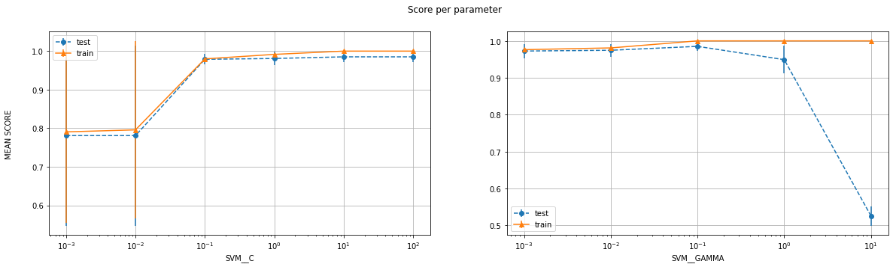

#################################################################################

Labels: 4 , 6  
Number of features: 25

#################################################################################

Number of training examples: (472, 25) (472, 1)  
Number of test examples: (119, 25) (119, 1)

--------------------------LIBSVM-----------------------------

The Best parameters according to grid search are: {'SVM__C': 1.0, 'SVM__gamma': 0.1}  
Training score for LIBSVM with best parameters: 100.0 %  
Test score for LIBSVM with best parameters: 99.15966386554622 %  
Indices of support vectors as returned by LIBSVM: [0, 1, 2, 3, 4, 5, 7, 8, 10, 11, 12, 14, 15, 16, 18, 19, 20, 22, 25, 27, 29, 30, 31, 32, 33, 36, 37, 38, 39, 40, 43, 44, 45, 46, 48, 51, 52, 54, 56, 58, 59, 60, 61, 62, 64, 65, 66, 67, 68, 69, 70, 71, 73, 75, 76, 77, 78, 80, 81, 83, 85, 88, 89, 91, 92, 93, 94, 95, 96, 97, 98, 104, 106, 108, 110, 111, 113, 116, 120, 121, 124, 125, 126, 127, 128, 129, 130, 132, 133, 134, 136, 137, 139, 140, 141, 142, 143, 144, 145, 148, 150, 153, 155, 156, 158, 159, 160, 163, 164, 166, 168, 170, 171, 172, 174, 175, 176, 179, 180, 181, 182, 183, 185, 186, 187, 188, 191, 193, 194, 197, 199, 201, 204, 206, 209, 210, 211, 213, 215, 216, 217, 220, 221, 222, 223, 224, 229, 230, 231, 232, 234, 235, 236, 238, 239, 240, 241, 242, 243, 245, 246, 247, 250, 251, 252, 256, 257, 258, 259, 260, 262, 263, 264, 265, 266, 267, 269, 270, 271, 272, 275, 276, 278, 279, 280, 281, 286, 287, 288, 289, 290, 292, 293, 294, 295, 296, 297, 299, 302, 303, 304, 305, 306, 307, 308, 309, 311, 314, 315, 316, 318, 319, 320, 321, 324, 326, 327, 329, 330, 331, 334, 336, 337, 338, 339, 340, 341, 342, 343, 346, 347, 348, 349, 350, 351, 352, 353, 356, 358, 361, 362, 364, 365, 366, 367, 368, 370, 372, 373, 374, 375, 376, 378, 379, 381, 382, 383, 384, 385, 388, 389, 390, 393, 394, 395, 396, 397, 399, 401, 403, 404, 405, 406, 407, 410, 411, 412, 414, 415, 417, 418, 419, 420, 421, 423, 424, 425, 426, 428, 429, 431, 433, 435, 437, 438, 439, 440, 441, 442, 446, 447, 448, 449, 450, 454, 455, 457, 458, 459, 460, 462, 463, 464, 465, 467, 468, 469, 471]

--------------------------CVXOPT-----------------------------

Test score for CVXOPT with best parameters: 99.15966386554622 %  
Indices of support vectors as returned by CVXOPT: [0, 1, 2, 3, 4, 5, 7, 8, 10, 11, 12, 14, 15, 16, 18, 19, 20, 22, 25, 27, 29, 30, 31, 32, 33, 36, 37, 38, 39, 40, 43, 44, 45, 46, 48, 51, 52, 54, 56, 58, 59, 60, 61, 62, 64, 65, 66, 67, 68, 69, 70, 71, 73, 75, 76, 77, 78, 80, 81, 83, 85, 88, 89, 91, 92, 93, 94, 95, 96, 97, 98, 102, 104, 106, 108, 110, 111, 113, 116, 120, 121, 124, 125, 126, 127, 128, 129, 130, 132, 133, 134, 136, 137, 139, 140, 141, 142, 143, 144, 145, 148, 150, 153, 155, 156, 158, 159, 160, 163, 164, 166, 168, 170, 171, 172, 174, 175, 176, 179, 180, 181, 182, 183, 185, 186, 187, 188, 191, 193, 194, 197, 199, 201, 204, 206, 209, 210, 211, 213, 215, 216, 217, 220, 221, 222, 223, 224, 229, 230, 231, 232, 234, 235, 236, 238, 239, 240, 241, 242, 243, 245, 246, 247, 250, 251, 252, 256, 257, 258, 259, 260, 262, 263, 264, 265, 266, 267, 269, 270, 271, 272, 275, 276, 278, 279, 280, 281, 286, 287, 288, 289, 290, 292, 293, 294, 295, 296, 297, 299, 302, 303, 304, 305, 306, 307, 308, 309, 311, 314, 315, 316, 318, 319, 320, 321, 324, 326, 327, 329, 330, 331, 334, 336, 337, 338, 339, 340, 341, 342, 343, 346, 347, 348, 349, 350, 351, 352, 353, 356, 358, 361, 362, 364, 365, 366, 367, 368, 370, 372, 373, 374, 375, 376, 378, 379, 381, 382, 383, 384, 385, 388, 389, 390, 393, 394, 395, 396, 397, 399, 401, 403, 404, 405, 406, 407, 410, 411, 412, 414, 415, 417, 418, 419, 420, 421, 423, 424, 425, 426, 428, 429, 431, 433, 435, 437, 438, 439, 440, 441, 442, 446, 447, 448, 449, 450, 454, 455, 457, 458, 459, 460, 462, 463, 464, 465, 467, 468, 469, 471]

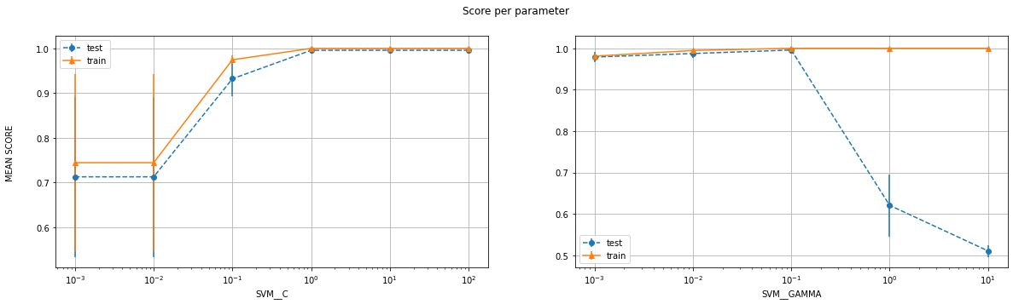

#################################################################################

Labels: 8 , 9  
Number of features: 10

#################################################################################

Number of training examples: (454, 10) (454, 1)  
Number of test examples: (114, 10) (114, 1)

--------------------------LIBSVM-----------------------------

The Best parameters according to grid search are: {'SVM__C': 1.0, 'SVM__gamma': 0.1}  
Training score for LIBSVM with best parameters: 98.45814977973568 %  
Test score for LIBSVM with best parameters: 98.24561403508771 %  
Indices of support vectors as returned by LIBSVM: [3, 8, 10, 11, 12, 13, 14, 20, 21, 24, 30, 32, 33, 34, 36, 37, 40, 42, 44, 45, 46, 49, 51, 53, 57, 58, 62, 63, 64, 70, 77, 79, 82, 83, 90, 96, 97, 101, 106, 108, 112, 116, 127, 130, 131, 132, 133, 137, 139, 141, 142, 144, 149, 153, 157, 163, 169, 172, 180, 181, 182, 184, 188, 190, 191, 194, 199, 202, 207, 212, 213, 216, 220, 221, 223, 224, 225, 227, 229, 230, 231, 236, 239, 242, 244, 245, 248, 252, 253, 259, 260, 261, 263, 265, 266, 267, 268, 272, 273, 275, 276, 278, 280, 283, 284, 288, 289, 293, 297, 298, 299, 301, 303, 304, 310, 313, 315, 318, 322, 323, 326, 329, 331, 334, 337, 340, 349, 350, 351, 353, 355, 359, 360, 362, 364, 365, 371, 375, 376, 377, 380, 381, 384, 388, 390, 392, 394, 395, 396, 397, 398, 399, 402, 403, 404, 407, 408, 410, 412, 414, 415, 416, 418, 423, 425, 426, 428, 430, 433, 435, 436, 437, 439, 442, 448, 450]

--------------------------CVXOPT-----------------------------

Test score for CVXOPT with best parameters: 98.24561403508773 %  
Indices of support vectors as returned by CVXOPT: [3, 8, 10, 11, 12, 13, 14, 20, 21, 24, 30, 32, 33, 34, 36, 37, 40, 42, 44, 45, 46, 49, 51, 53, 57, 58, 62, 63, 64, 70, 77, 79, 82, 83, 90, 96, 97, 101, 106, 108, 112, 113, 116, 127, 130, 131, 132, 133, 137, 139, 140, 141, 142, 144, 149, 153, 157, 163, 164, 169, 172, 180, 181, 182, 184, 188, 190, 191, 194, 199, 202, 207, 212, 213, 216, 220, 221, 223, 224, 225, 227, 229, 230, 231, 236, 239, 242, 244, 245, 248, 252, 253, 256, 259, 260, 261, 263, 265, 266, 267, 268, 272, 273, 275, 276, 278, 280, 283, 284, 288, 289, 293, 297, 298, 299, 301, 303, 304, 310, 313, 315, 318, 322, 323, 326, 329, 331, 334, 337, 340, 349, 350, 351, 353, 355, 359, 360, 362, 364, 365, 371, 375, 376, 377, 380, 381, 384, 388, 390, 392, 394, 395, 396, 397, 398, 399, 402, 403, 404, 407, 408, 410, 412, 414, 415, 416, 418, 423, 425, 426, 428, 430, 433, 435, 436, 437, 439, 442, 448, 450]

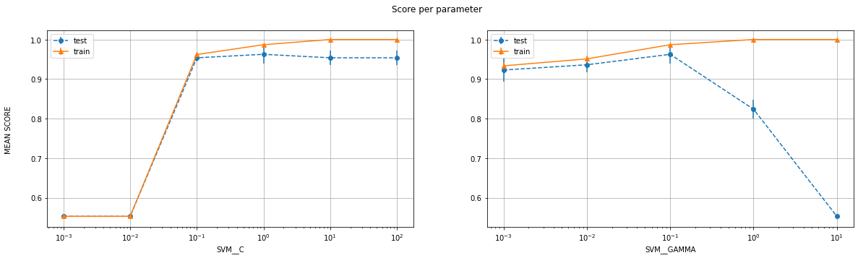

#################################################################################

Labels: 8 , 9

Number of features: 25

#################################################################################

Number of training examples: (454, 25) (454, 1)  
Number of test examples: (114, 25) (114, 1)

--------------------------LIBSVM-----------------------------

The Best parameters according to grid search are: {'SVM__C': 10.0, 'SVM__gamma': 0.01}  
Training score for LIBSVM with best parameters: 100.0 %  
Test score for LIBSVM with best parameters: 98.24561403508771 %  
Indices of support vectors as returned by LIBSVM: [3, 28, 33, 44, 45, 57, 58, 62, 64, 70, 76, 79, 84, 101, 102, 132, 149, 153, 155, 157, 172, 180, 191, 199, 201, 202, 212, 224, 229, 230, 231, 236, 244, 245, 253, 260, 261, 266, 267, 278, 288, 297, 304, 315, 323, 326, 330, 331, 340, 351, 355, 369, 373, 377, 380, 381, 390, 392, 400, 403, 406, 407, 408, 412, 414, 415, 416, 431, 439, 443, 448, 450]

--------------------------CVXOPT-----------------------------

Test score for CVXOPT with best parameters: 98.24561403508773 %  
Indices of support vectors as returned by CVXOPT: [3, 28, 33, 44, 45, 57, 58, 62, 64, 70, 76, 79, 84, 101, 102, 132, 149, 153, 155, 157, 172, 180, 191, 199, 201, 202, 212, 224, 229, 230, 231, 236, 244, 245, 253, 260, 261, 266, 267, 278, 288, 297, 304, 315, 323, 326, 330, 331, 340, 351, 355, 369, 373, 377, 380, 381, 390, 392, 400, 403, 406, 407, 408, 412, 414, 415, 416, 431, 439, 443, 448, 450]

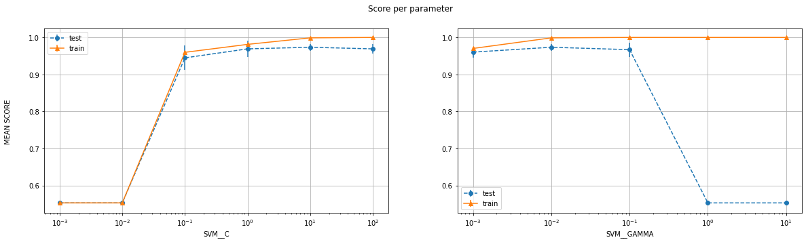

**RBF Kernel**

|  |  |  |  |  |  |  |  |
| --- | --- | --- | --- | --- | --- | --- | --- |
| **Class A** | **Class B** | **Num of features** | **Best C** | **Best gamma** | **SVM train score** | **SVM test score** | **CVXOPT test score** |
| 0 | 1 | 10 | 0.1 | 0.1 | 99.59% | 99.17% | 99.17% |
| 0 | 1 | 25 | 100 | 0.001 | 100% | 99.17% | 99.17% |
| 4 | 6 | 10 | 10 | 0.1 | 100% | 100% | 100% |
| 4 | 6 | 25 | 1 | 0.1 | 100% | 99.16% | 99.16% |
| 8 | 9 | 10 | 1 | 0.1 | 98.46% | 98.25% | 98.25% |
| 8 | 9 | 25 | 10 | 0.01 | 100% | 98.25% | 98.25% |

Table 3

**Discussion**

By looking at the table 3, we can see that as the number of features increase, the test accuracy either remains the same or increases, which is also what we expect because we are increasing the complexity of the model. However, there is a slight anomaly for the pair (4,6) as increasing features is actually hurting its test set performance. I do not know why this might be happening.

As stated in the discussion for the poly kernel, we see that at lower values of the parameters, the model underfits the data and as we keep increasing their value, the training accuracy also keeps increasing. Same, however, cannot be said about the test error which is also what we expect

* **Sigmoid Kernel**
* The sigmoid kernel has the same parameters as the RBF kernel, and is therefore iterated over and plotted in the same fashion. The results are tabulated in table 4

Note: Zoom in on the graph for better visibility

#################################################################################

Labels: 0 , 1  
Number of features: 25

#################################################################################

Number of training examples: (484, 25) (484, 1)  
Number of test examples: (121, 25) (121, 1)

--------------------------LIBSVM-----------------------------

The Best parameters according to grid search are: {'SVM__C': 10.0, 'SVM__gamma': 0.01}  
Training score for LIBSVM with best parameters: 100.0 %  
Test score for LIBSVM with best parameters: 99.17355371900827 %  
Indices of support vectors as returned by LIBSVM: [13, 19, 78, 96, 149, 176, 261, 275, 282, 285, 322, 346, 372, 382, 403, 472]

--------------------------CVXOPT-----------------------------

Test score for CVXOPT with best parameters: 99.17355371900827 %  
Indices of support vectors as returned by CVXOPT: [13, 19, 27, 78, 96, 149, 176, 261, 275, 282, 285, 322, 346, 372, 382, 403, 472]

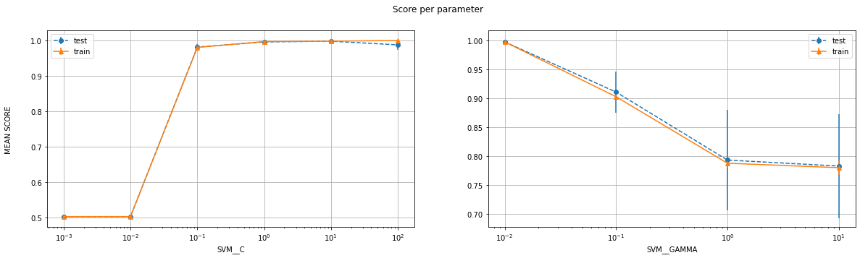

#################################################################################

Labels: 0 , 1

Number of features: 10

#################################################################################

Number of training examples: (484, 10) (484, 1)

Number of test examples: (121, 10) (121, 1)

--------------------------LIBSVM-----------------------------

The Best parameters according to grid search are: {'SVM__C': 1.0, 'SVM__gamma': 0.01}

Training score for LIBSVM with best parameters: 99.58677685950413 %

Test score for LIBSVM with best parameters: 100.0 %

Indices of support vectors as returned by LIBSVM: [4, 13, 14, 19, 24, 41, 78, 84, 96, 118, 119, 133, 135, 144, 149, 161, 162, 163, 176, 192, 197, 199, 261, 275, 280, 284, 285, 304, 313, 346, 382, 395, 403, 432, 445, 454, 456, 467, 469, 472]

--------------------------CVXOPT-----------------------------

Test score for CVXOPT with best parameters: 100.0 %

Indices of support vectors as returned by CVXOPT: [4, 13, 14, 19, 24, 41, 78, 84, 96, 118, 119, 133, 135, 144, 149, 161, 162, 163, 176, 192, 197, 199, 261, 275, 280, 284, 285, 304, 313, 346, 382, 395, 403, 432, 445, 454, 456, 467, 469, 472]

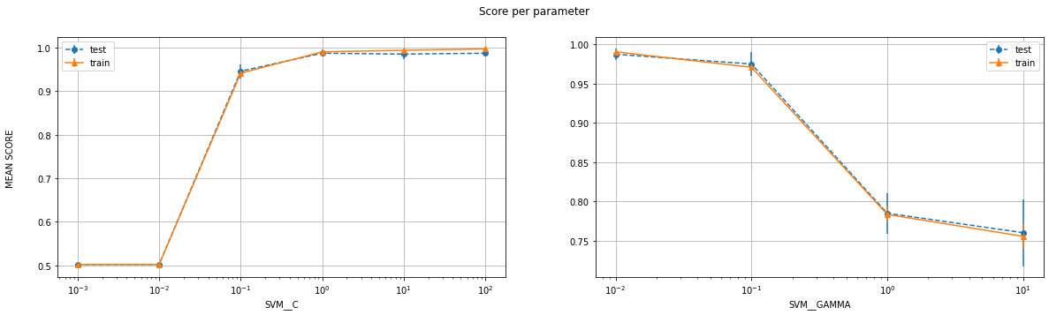

#################################################################################

Labels: 8 , 9

Number of features: 25

#################################################################################

Number of training examples: (454, 25) (454, 1)

Number of test examples: (114, 25) (114, 1)

--------------------------LIBSVM-----------------------------

The Best parameters according to grid search are: {'SVM__C': 1.0, 'SVM__gamma': 0.01}

Training score for LIBSVM with best parameters: 96.47577092511013 %

Test score for LIBSVM with best parameters: 96.49122807017544 %

Indices of support vectors as returned by LIBSVM: [1, 3, 7, 8, 13, 14, 15, 17, 20, 24, 28, 29, 33, 34, 37, 42, 44, 45, 53, 57, 58, 59, 62, 72, 76, 79, 82, 83, 90, 95, 101, 108, 109, 112, 117, 132, 134, 137, 149, 153, 157, 172, 180, 186, 190, 191, 199, 201, 202, 212, 223, 224, 225, 226, 229, 230, 231, 233, 236, 237, 244, 248, 251, 253, 256, 260, 261, 267, 275, 278, 281, 282, 283, 288, 294, 297, 298, 299, 301, 314, 315, 322, 323, 325, 326, 327, 330, 331, 340, 351, 355, 358, 362, 369, 373, 376, 377, 380, 381, 390, 392, 398, 399, 400, 403, 406, 407, 408, 410, 412, 414, 415, 416, 418, 419, 420, 427, 431, 433, 435, 437, 439, 441, 443, 448, 450]

--------------------------CVXOPT-----------------------------

Test score for CVXOPT with best parameters: 96.49122807017544 %

Indices of support vectors as returned by CVXOPT: [1, 3, 7, 8, 13, 14, 15, 17, 20, 24, 28, 29, 33, 34, 37, 42, 44, 45, 53, 57, 58, 59, 62, 72, 76, 79, 82, 83, 90, 95, 101, 108, 109, 112, 117, 132, 134, 137, 149, 153, 157, 172, 180, 186, 190, 191, 199, 201, 202, 212, 223, 224, 225, 226, 229, 230, 231, 233, 236, 237, 244, 248, 251, 253, 256, 260, 261, 267, 275, 278, 281, 282, 283, 288, 294, 297, 298, 299, 301, 314, 315, 322, 323, 325, 326, 327, 330, 331, 340, 351, 355, 358, 362, 369, 373, 376, 377, 380, 381, 390, 392, 398, 399, 400, 403, 406, 407, 408, 410, 412, 414, 415, 416, 418, 419, 420, 427, 431, 433, 435, 437, 439, 441, 443, 448, 450]

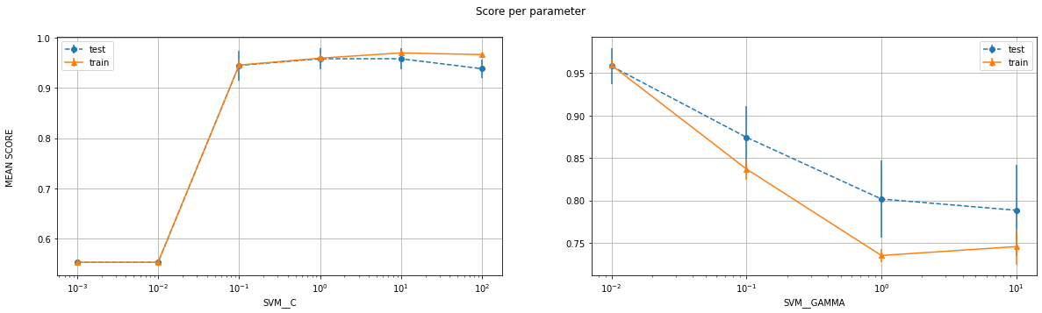

#################################################################################

Labels: 8 , 9

Number of features: 10

#################################################################################

Number of training examples: (454, 10) (454, 1)

Number of test examples: (114, 10) (114, 1)

--------------------------LIBSVM-----------------------------

The Best parameters according to grid search are: {'SVM__C': 1.0, 'SVM__gamma': 0.01}

Training score for LIBSVM with best parameters: 92.95154185022027 %

Test score for LIBSVM with best parameters: 93.85964912280701 %

Indices of support vectors as returned by LIBSVM: [3, 7, 8, 10, 13, 14, 15, 20, 24, 29, 33, 34, 36, 37, 42, 45, 53, 57, 59, 62, 70, 75, 79, 82, 83, 86, 90, 97, 101, 108, 109, 112, 114, 132, 134, 137, 138, 141, 146, 148, 149, 150, 153, 157, 163, 167, 172, 180, 186, 194, 198, 199, 201, 202, 209, 211, 212, 215, 221, 223, 224, 225, 226, 229, 230, 233, 236, 237, 242, 248, 251, 256, 260, 261, 263, 265, 266, 267, 273, 275, 276, 278, 282, 283, 286, 287, 288, 294, 297, 298, 299, 300, 315, 322, 323, 325, 326, 329, 330, 331, 332, 337, 340, 342, 351, 355, 358, 362, 367, 369, 370, 371, 375, 376, 380, 381, 384, 386, 388, 389, 391, 396, 398, 399, 400, 403, 406, 407, 408, 410, 412, 414, 415, 416, 418, 419, 420, 421, 423, 427, 430, 431, 432, 433, 435, 439, 440, 441, 448, 450]

--------------------------CVXOPT-----------------------------

Test score for CVXOPT with best parameters: 93.85964912280701 %

Indices of support vectors as returned by CVXOPT: [3, 7, 8, 10, 13, 14, 15, 17, 20, 24, 29, 33, 34, 36, 37, 42, 45, 53, 57, 59, 62, 70, 75, 79, 82, 83, 86, 90, 97, 101, 108, 109, 112, 114, 132, 134, 137, 138, 141, 146, 148, 149, 150, 153, 157, 163, 167, 172, 180, 186, 194, 198, 199, 201, 202, 209, 211, 212, 215, 221, 223, 224, 225, 226, 229, 230, 233, 236, 237, 242, 248, 251, 256, 260, 261, 263, 265, 266, 267, 273, 275, 276, 278, 282, 283, 286, 287, 288, 294, 297, 298, 299, 300, 309, 315, 322, 323, 325, 326, 329, 330, 331, 332, 337, 340, 342, 351, 355, 358, 362, 367, 369, 370, 371, 375, 376, 380, 381, 384, 386, 388, 389, 391, 396, 398, 399, 400, 403, 406, 407, 408, 410, 412, 414, 415, 416, 418, 419, 420, 421, 423, 427, 430, 431, 432, 433, 435, 439, 440, 441, 448, 450]

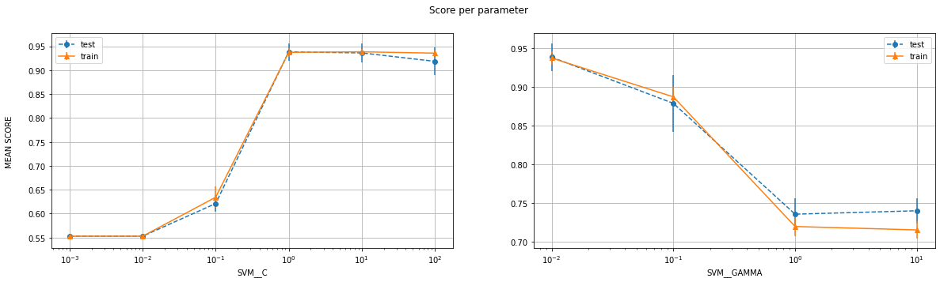

#################################################################################

Labels: 4 , 6

Number of features: 25

#################################################################################

Number of training examples: (472, 25) (472, 1)

Number of test examples: (119, 25) (119, 1)

--------------------------LIBSVM-----------------------------

The Best parameters according to grid search are: {'SVM__C': 10.0, 'SVM__gamma': 0.01}

Training score for LIBSVM with best parameters: 98.30508474576271 %

Test score for LIBSVM with best parameters: 100.0 %

Indices of support vectors as returned by LIBSVM: [0, 11, 14, 43, 44, 51, 52, 61, 66, 73, 83, 106, 133, 140, 142, 150, 153, 164, 170, 194, 199, 234, 235, 272, 275, 276, 280, 289, 294, 302, 306, 319, 352, 381, 390, 393, 395, 414, 420, 440, 450]

--------------------------CVXOPT-----------------------------

Test score for CVXOPT with best parameters: 100.0 %

Indices of support vectors as returned by CVXOPT: [0, 11, 14, 43, 44, 51, 52, 61, 66, 73, 83, 106, 133, 140, 142, 150, 153, 164, 170, 194, 199, 234, 235, 236, 272, 275, 276, 280, 289, 294, 302, 319, 352, 381, 382, 390, 395, 414, 420, 440, 450]

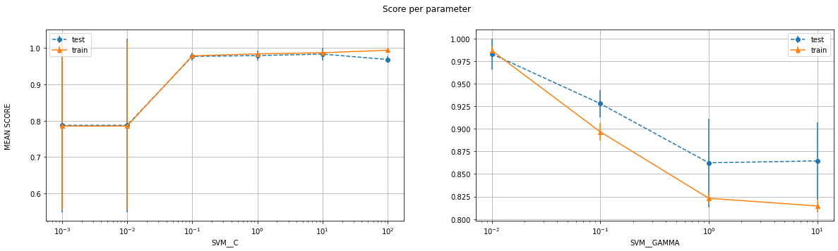

#################################################################################

Labels: 4 , 6

Number of features: 10

#################################################################################

Number of training examples: (472, 10) (472, 1)

Number of test examples: (119, 10) (119, 1)

--------------------------LIBSVM-----------------------------

The Best parameters according to grid search are: {'SVM__C': 0.1, 'SVM__gamma': 0.1}

Training score for LIBSVM with best parameters: 94.91525423728814 %

Test score for LIBSVM with best parameters: 94.11764705882352 %

Indices of support vectors as returned by LIBSVM: [0, 1, 3, 4, 10, 11, 14, 24, 25, 33, 40, 43, 44, 46, 47, 51, 52, 54, 58, 60, 61, 62, 66, 71, 76, 77, 91, 92, 93, 94, 108, 109, 110, 117, 120, 123, 126, 139, 140, 141, 142, 145, 147, 149, 150, 153, 158, 160, 161, 162, 164, 170, 174, 180, 182, 202, 210, 215, 217, 220, 221, 224, 228, 230, 235, 236, 238, 239, 241, 242, 244, 246, 255, 256, 257, 258, 262, 265, 266, 267, 271, 272, 273, 275, 276, 277, 280, 281, 289, 294, 296, 297, 299, 300, 302, 303, 305, 308, 314, 316, 319, 321, 328, 331, 332, 335, 339, 340, 341, 342, 348, 357, 358, 364, 370, 375, 376, 378, 380, 381, 382, 384, 385, 389, 390, 393, 394, 395, 397, 403, 406, 409, 411, 412, 415, 420, 421, 423, 427, 435, 436, 440, 447, 450, 455, 460, 468, 469]

--------------------------CVXOPT-----------------------------

My CVXOPT returned an arithmetic error related to rank for this which I could not rectify

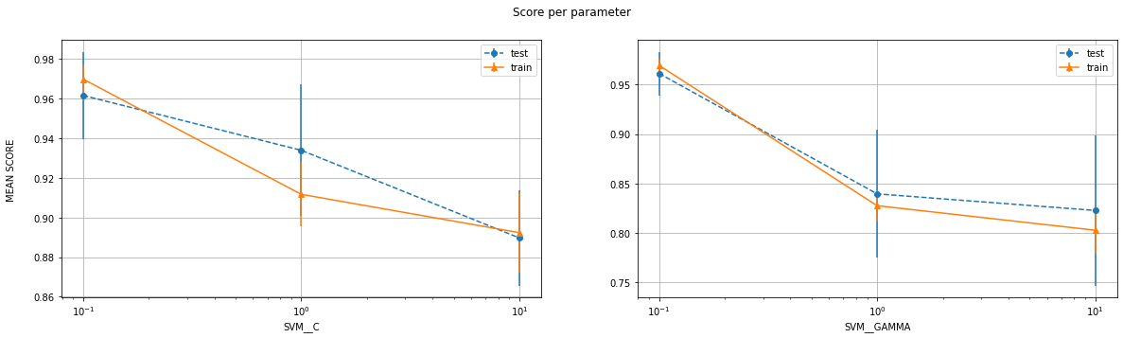

**Sigmoid Kernel**

|  |  |  |  |  |  |  |  |
| --- | --- | --- | --- | --- | --- | --- | --- |
| **Class A** | **Class B** | **Num of features** | **Best C** | **Best gamma** | **SVM train score** | **SVM test score** | **CVXOPT test score** |
| 0 | 1 | 10 | 1 | 0.01 | 99.59% | 100% | 100% |
| 0 | 1 | 25 | 10 | 0.01 | 100% | 99.17% | 99.17% |
| 4 | 6 | 10 | 0.1 | 0.1 | 94.92% | 94.12% | - |
| 4 | 6 | 25 | 10 | 0.01 | 98.31% | 100% | 100% |
| 8 | 9 | 10 | 1 | 0.01 | 92.95% | 93.86% | 93.86% |
| 8 | 9 | 25 | 1 | 0.01 | 96.48% | 96.49% | 96.49% |

Table 4

**Discussion**

By looking at the table 4, we can easily conclude that as the number of features increase, the test accuracy either remains the same or increases, which is also what we expect because we are increasing the complexity of the model.

The one thing that makes this kernel different from the rest is that instead of just test error decreasing for larger values of gamma, both training and test error decrease. i.e., there is something in its internal functioning which has negative effect by larger values of gamma

* **Conclusion (Part 1A, Binary Classification)**

As mentioned in the individual sub-sections, it almost never hurt to increase the number of features as it only increased the accuracy. Moreover, other than gamma in few cases, the underfitting to overfitting change followed a similar trend.

One very important and validating (for me) thing that I also noticed was how the support vectors returned by CVXOPT and LIBSVM were almost exactly the same. I returned the indices of the support vector for that particular training set so anyone can manually confirm this. Also, the test score was the same for libsvm and cvxopt (barring a few exceptions) which is not surprising as the support vectors are the deciding factor for the classifier.

Now, I present the best parameters and scores for each of the kernels for each set of pairs for 25 features:

|  |  |  |  |  |  |  |  |
| --- | --- | --- | --- | --- | --- | --- | --- |
| **Pair** | **Kernel** | **Best C** | **Best degree** | **Best gamma** | **SVM train score** | **SVM test score** | **CVXOPT test score** |
| (0,1) | Linear | 0.1 | - | - | 100% | 99.17% | 99.17% |
| (0,1) | Poly | 0.001 | 1 | 100 | 100% | 99.17% | 99.17% |
| (0,1) | RBF | 100 | - | 0.001 | 100% | 99.17% | 99.17% |
| (0,1) | Sigmoid | 10 | - | 0.01 | 100% | 99.17% | 99.17% |
| (4,6) | Linear | 0.1 | - | - | 98.94% | 100% | 100% |
| (4,6) | Poly | 0.01 | 3 | 0.1 | 99.58% | 98.32% | 99.16% |
| (4,6) | RBF | 1 | - | 0.1 | 100% | 99.16% | 99.16% |
| (4,6) | Sigmoid | 10 | - | 0.01 | 98.31% | 100% | 100% |
| (8,9) | Linear | 0.1 | - | - | 97.14% | 97.37% | 97.37% |
| (8,9) | Poly | 0.01 | 1 | 10 | 97.14% | 97.37% | 97.37% |
| (8,9) | RBF | 10 | - | 0.01 | 100% | 98.25% | 98.25% |
| (8,9) | Sigmoid | 1 | - | 0.01 | 96.48% | 96.49% | 96.49% |

Table 5

Interestingly enough, a simple model with linear kernel performs really well for the dataset at hand. This might be because 25 features are good enough and we jut happen to have a good dataset. Or perhaps the projection to lower dimensions does our job for us

Although it is not guaranteed that the same hyperparameters give the best results (As we can see in our tables). But, barring a few outliers, the best score is generally for a small range of hyperparameters only

**Part 2**

My initial basic approach was to simply do a hyperparameter sweep for different kernels for the LIBSVM library. The pipeline contained a standard scaler followed by the SVM.SVC model. The results are as follows:

Number of training examples: (7200, 25) (7200, 1)  
Number of test examples: (800, 25) (800, 1)

--------------------------LIBSVM for LINEAR-----------------------------

Grid scaled training score for libsvm is: 92.88888888888889 %  
Grid scaled test score for libsvm is: 90.625 %  
The Best parameters according to grid search are: {'SVM__C': 0.1}

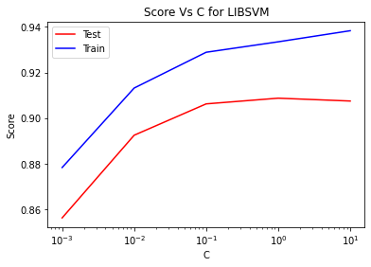

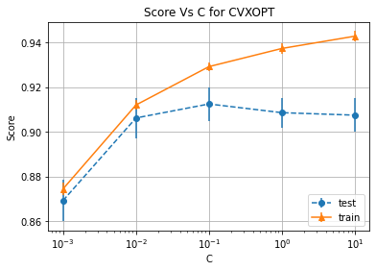

--------------------------LIBSVM for SIGMOID-----------------------------

Grid scaled training score for libsvm is: 91.625 %  
Grid scaled test score for libsvm is: 90.25 %  
The Best parameters according to grid search are: {'SVM__C': 10.0, 'SVM__gamma': 0.01}

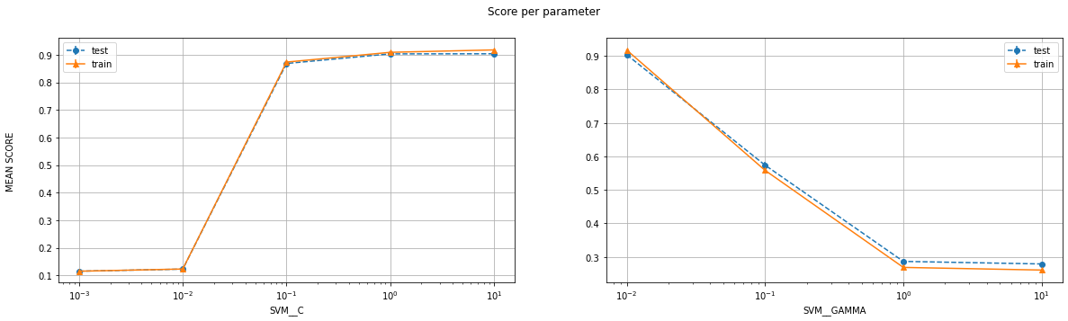

--------------------------LIBSVM for POLY-----------------------------

Grid scaled training score for libsvm is: 99.58333333333333 %  
Grid scaled test score for libsvm is: 96.5 %  
The Best parameters according to grid search are: {'SVM__C': 0.1, 'SVM__degree': 3.0, 'SVM__gamma': 0.1}

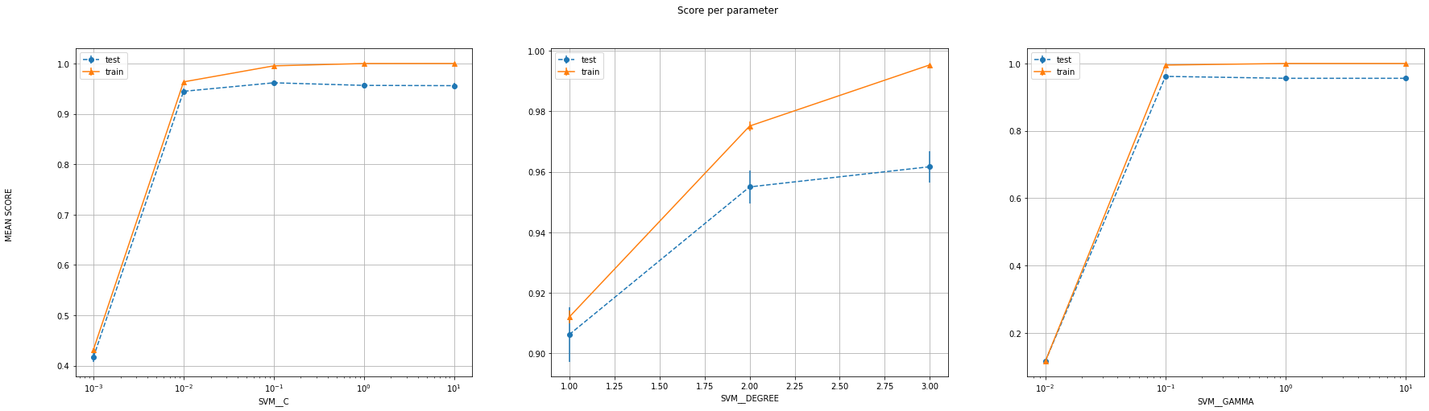

--------------------------LIBSVM for RBF-----------------------------

Grid scaled training score for libsvm is: 100.0 %  
Grid scaled test score for libsvm is: 96.875 %  
The Best parameters according to grid search are: {'SVM__C': 10.0, 'SVM__gamma': 0.1}

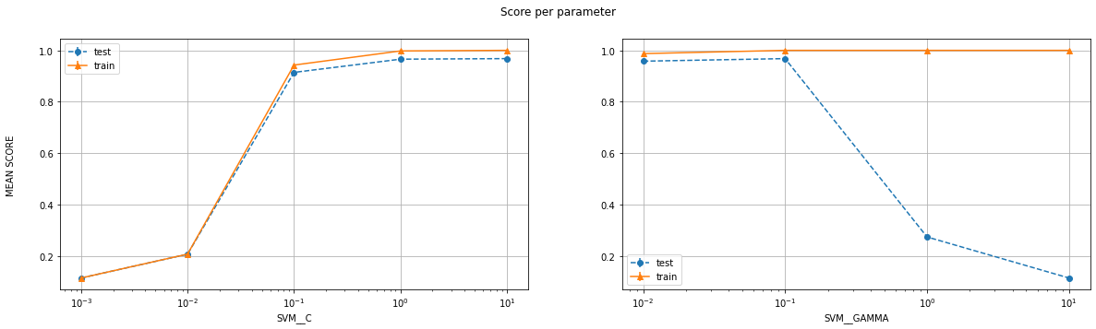

The best score was, as can be seen, given by RBF kernel, with parameters C=10 and gamma=0.1  
This (First_draft.csv) gave me an accuracy of 95.5% on the leaderboard

Since 15 submissions were allowed, I tried out the poly one too, with parameters C=0.1, degree=3, gamma=0.1  
This (second_draft.csv) gave a worse accuracy of 94.5%

Therefore, I decided to do a bigger sweep on just the RBF kernel. The results were as follows:

And eyeballing the different scores, I found C=100 to be better than C=10 for the same gamma of 0.1. This did, in fact, give me a better performance.

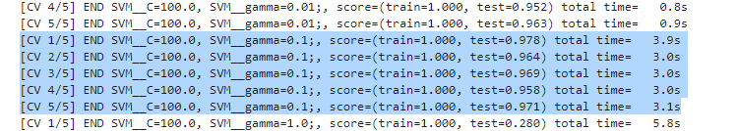

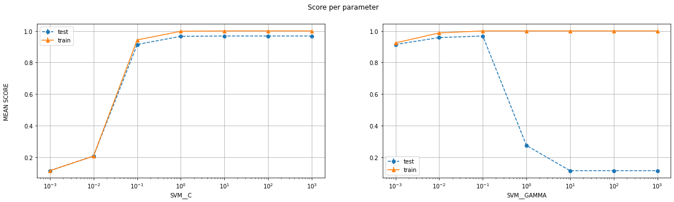

My next steps would be to do feature selection using some tools provided by the sklearn library. I can plot the correlation values among different features and the P value, and eliminate the highly dependant ones or the unimportant ones.

After that, I can retrain for all the different kernels, choose the top 2 best parameters of each kind (8 models) and use a voting classifier. i.e., I will pick the label which is returned by more than 50% of the classifiers. If no such label exists, I will provide some weight to different models based on their validation set accuracies and choose accordingly.

These 2 approaches can be done independently and together, and I plan on doing both.

**References** (For Code)  
Note: It is possible that codes in some of these references are not present in my current version of the code. But they certainly influenced my code

* <https://stats.stackexchange.com/questions/31066/what-is-the-influence-of-c-in-svms-with-linear-kernel>
* <https://stackoverflow.com/questions/37161563/how-to-graph-grid-scores-from-gridsearchcv>
* <https://courses.csail.mit.edu/6.867/wiki/images/a/a7/Qp-cvxopt.pdf>
* <https://www.robots.ox.ac.uk/~az/lectures/ml/lect3.pdf>
* <https://scikit-learn.org/stable/modules/generated/sklearn.svm.SVC.html>
* <https://xavierbourretsicotte.github.io/SVM_implementation.html>
* <https://www.discoverbits.in/701/find-the-indices-of-the-values-common-two-arrays-lists-python>
* <https://jakevdp.github.io/PythonDataScienceHandbook/04.12-three-dimensional-plotting.html>
* <https://matplotlib.org/2.0.2/mpl_toolkits/mplot3d/tutorial.html>
* <https://linuxtut.com/en/faba9e8b9c764a045e8e/> (Based on Ch7 PRML)